Reports Menu/HIPAA/Accounting Of Disclosure:

Request:

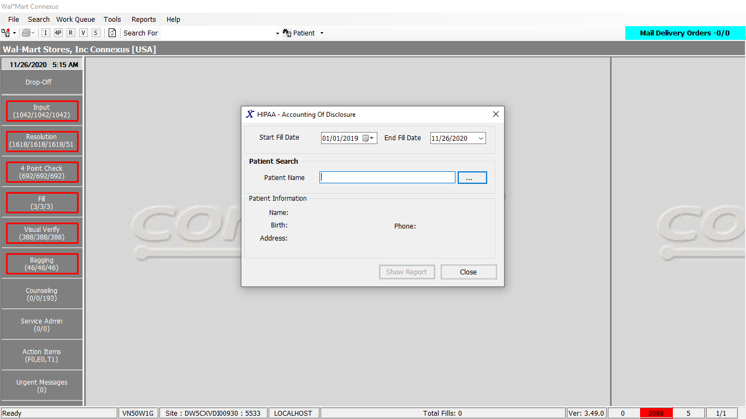

Response:

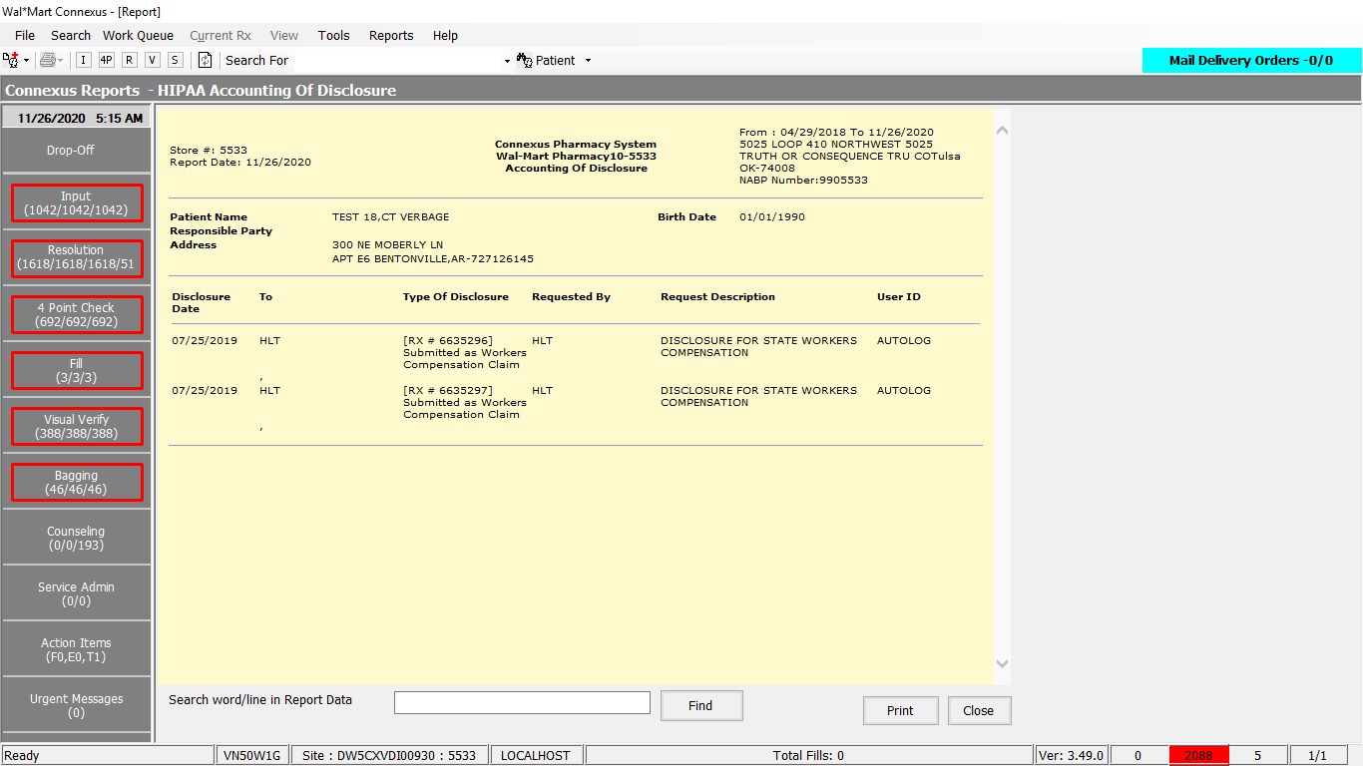

Queries:

1. Friend Const GetHIPAAAccountDisclosureSelect1 As String = "SELECT patient_id, last_name, first_name, middle_name, gender_code, birth_date, pri_prescriber_id, snap_cap_rqst_date, patient_label_name, pref_language_code, relt_patient_id, relt_last_name, relt_first_name, relt_middle_name, address_line_1, address_line_2, city_name, state_prov_code, postal_code, country_code, ssn, drivers_license, dl_state_code, HomePhone, WorkPhone, Email,comment_text, alt_packaging, ar_account, presc_first_name, presc_middle_name, presc_last_name, pri_clinic_id, charge_freq_code, mail_out_freq_code, patient_DAW, print_HL, dflt_addr_type_cd, hipaa_status_code FROM v_Patient WHERE patient_id = ?"

2. Friend Const GetHIPAAAccountDisclosureSelect2 As String = "SELECT hir.disclosure_ts,hir.hipaa_info_rqst_id, " &

"hir.requestor_type_cd, hir.rqstg_party_id, hir.requestor_name, CASE WHEN hir.requestor_type_cd = ? " &

"THEN ag.hipaa_agency_name WHEN hir.requestor_type_cd IN ( ?,? ) THEN pc.phm_co_name_abbr " &

"END DisclosureName, sa.address_line_1, sa.address_line_2, sa.city_name, sa.state_prov_code Addrstate_code, " &

"sa.postal_code, hir.create_userid , CASE WHEN hir.request_type_code IN ( ?,?,? ) THEN pct.code_desc WHEN " &

"hir.request_type_code IN ( ?,?,?,? ) THEN '[RX # ' || rx.rx_nbr || '] ' || ' ' || pct.code_desc " &

"ELSE '[RX # ' || rx.rx_nbr || '] 'END code_desc, hir.request_txt FROM hipaa_info_request hir, " &

"hipaa_info_rqst_rx hirx, rx rx, OUTER hipaa_agency ag, OUTER phm_company pc,OUTER pharmacy_code_txt pct, " &

"OUTER subject_address sa WHERE hir.hipaa_info_rqst_id = hirx.hipaa_info_rqst_id AND rx.rx_id = hirx.rx_id " &

"AND hir.rqstg_party_id = ag.hipaa_agency_id AND hir.rqstg_party_id = pc.phm_co_id AND " &

"hir.request_type_code = pct.code_id AND sa.subject_id = hir.rqstg_party_id AND sa.subject_type_code = CASE " &

"WHEN hir.requestor_type_cd = ? THEN ? WHEN hir.requestor_type_cd IN ( ?,? ) THEN ? END AND " &

"date(hir.disclosure_ts) >= ? AND date(hir.disclosure_ts) <= ? AND hir.disclosure_ts is NOT NULL AND " &

"hir.requestor_type_cd NOT IN ( ?,?, 0 ) AND date(hir.disclosure_ts) >= ? AND rx.patient_id = ? UNION " &

"SELECT hir.disclosure_ts,hir.hipaa_info_rqst_id, hir.requestor_type_cd, hir.rqstg_party_id, hir.requestor_name," &

"trim(nvl(pa.last_name,'')) || ',' || trim(nvl(pa.first_name,'')) || ' ' || trim(nvl(pa.middle_name,'')) " &

"DisclosureName, sa.address_line_1, sa.address_line_2, sa.city_name, sa.state_prov_code " &

"Addrstate_code, sa.postal_code, hir.create_userid , pct.code_desc, hir.request_txt FROM hipaa_info_request hir," &

"patient pa,OUTER pharmacy_code_txt pct, OUTER subject_address sa WHERE hir.requestor_type_cd = ? AND " &

"hir.rqstg_party_id = pa.patient_id AND hir.request_type_code = pct.code_id AND sa.subject_id = hir.rqstg_party_id " &

"AND sa.subject_type_code = ? AND date(hir.disclosure_ts) >= ? AND date(hir.disclosure_ts) <= ? AND " &

"hir.disclosure_ts is NOT NULL AND date(hir.disclosure_ts) >= ? AND pa.patient_id = ? UNION " &

"SELECT hir.disclosure_ts,hir.hipaa_info_rqst_id, hir.requestor_type_cd, hir.rqstg_party_id," &

"hir.requestor_name, CASE WHEN hir.requestor_type_cd = ? THEN ag.hipaa_agency_name END DisclosureName, " &

"sa.address_line_1, sa.address_line_2, sa.city_name, sa.state_prov_code Addrstate_code, sa.postal_code," &

"hir.create_userid , pct.code_desc, hir.request_txt FROM hipaa_info_request hir, hipaa_rqst_patient hirp," &

"patient pat, OUTER hipaa_agency ag,OUTER pharmacy_code_txt pct, OUTER subject_address sa WHERE " &

"hir.hipaa_info_rqst_id = hirp.hipaa_info_rqst_id AND pat.patient_id = hirp.patient_id AND " &

"hir.rqstg_party_id = ag.hipaa_agency_id AND hir.request_type_code = pct.code_id AND sa.subject_id = " &

"hir.rqstg_party_id AND sa.subject_type_code = ? AND date(hir.disclosure_ts) >= ? AND " &

"date(hir.disclosure_ts) <= ? AND hir.disclosure_ts is NOT NULL AND hir.requestor_type_cd NOT IN ( ?,? , 0 ) " &

"AND date(hir.disclosure_ts) >= ? AND pat.patient_id = ? "

DAL:

Public Function GetHipaaAccountDisclosure(ByVal siteId As Integer, ByVal patientId As Integer,

ByVal startDate As Date, ByVal endDate As Date,

ByVal hipaaLegalDate As Date) As HipaaAccountDisclosureBE Implements IReportDAL.GetHipaaAccountDisclosure

Using (New Tracer(ConnexusCommonConstants.ConnexusTracer))

Dim patientGeneralInfo As PatGeneralInfoBE = Nothing

patientGeneralInfo = GetBasicPatientInfoForHipaa(siteId, patientId)

Dim querySQL As String

querySQL = ReportQueries.GetHIPAAAccountDisclosureSelect2

Dim paramList As New List(Of DbParameter)

paramList.AddParameter(DbType.Int16, ServiceCommon.HIPAAInvestigation, "RequestorTypeCD1")

paramList.AddParameter(DbType.Int16, ServiceCommon.HIPAAInsuranceInvestigation, "RequestorTypeCD2")

paramList.AddParameter(DbType.Int16, ServiceCommon.HIPAAAutomaticLogging, "RequestorTypeCD3")

paramList.AddParameter(DbType.Int16, HipaaReportTypes.DesRcrd, "RequestTypeCode1")

paramList.AddParameter(DbType.Int16, HipaaReportTypes.DisclRpt, "RequestTypeCode2")

paramList.AddParameter(DbType.Int16, HipaaReportTypes.MedExp, "RequestTypeCode3")

paramList.AddParameter(DbType.Int16, HipaaReportTypes.WCLOG, "RequestTypeCode4")

paramList.AddParameter(DbType.Int16, HipaaReportTypes.INSAUDT, "RequestTypeCode5")

paramList.AddParameter(DbType.Int16, HipaaReportTypes.RXIMGPRT, "RequestTypeCode6")

paramList.AddParameter(DbType.Int16, HipaaReportTypes.SIGIMGPT, "RequestTypeCode7")

paramList.AddParameter(DbType.Int16, ServiceCommon.HIPAAInvestigation, "ReqstorTypeCD1")

paramList.AddParameter(DbType.Int16, SubjectTypeCode.HIPAA, "AgencySubjectCode")

paramList.AddParameter(DbType.Int16, ServiceCommon.HIPAAInsuranceInvestigation, "ReqstorTypeCD2")

paramList.AddParameter(DbType.Int16, ServiceCommon.HIPAAAutomaticLogging, "ReqstorTypeCD3")

paramList.AddParameter(DbType.Int16, SubjectTypeCode.Clinic, "ClinicSubjectCode")

paramList.AddParameter(DbType.DateTime, startDate, "DisclosureTS1")

paramList.AddParameter(DbType.DateTime, endDate, "DisclosureTS2")

paramList.AddParameter(DbType.Int16, ServiceCommon.HIPAAInternalUser, "RequestorTypeCD4")

paramList.AddParameter(DbType.Int16, ServiceCommon.HIPAAPatientRequest, "RequestorTypeCD5")

paramList.AddParameter(DbType.DateTime, hipaaLegalDate, "DisclosureTS3")

paramList.AddParameter(DbType.Int32, patientId, "PatientId")

paramList.AddParameter(DbType.Int16, ServiceCommon.HIPAAPatientRequest, "RequestorTypeCD5")

paramList.AddParameter(DbType.Int16, SubjectTypeCode.Patient, "PatientSubjectCode")

paramList.AddParameter(DbType.DateTime, startDate, "DisclosureTS1")

paramList.AddParameter(DbType.DateTime, endDate, "DisclosureTS2")

paramList.AddParameter(DbType.DateTime, hipaaLegalDate, "DisclosureTS3")

paramList.AddParameter(DbType.Int32, patientId, "PatientId")

paramList.Add(ParameterHelper.BuildParameter("RequestorTypeCD1", DbType.Int16, ServiceCommon.HIPAAInvestigation))

paramList.AddParameter(DbType.Int16, SubjectTypeCode.HIPAA, "AgencySubjectCode1")

paramList.AddParameter(DbType.DateTime, startDate, "DisclosureTS1")

paramList.AddParameter(DbType.DateTime, endDate, "DisclosureTS2")

paramList.AddParameter(DbType.Int16, ServiceCommon.HIPAAInternalUser, "RequestorTypeCD4")

paramList.AddParameter(DbType.Int16, ServiceCommon.HIPAAPatientRequest, "RequestorTypeCD5")

paramList.AddParameter(DbType.DateTime, hipaaLegalDate, "DisclosureTS3")

paramList.AddParameter(DbType.Int32, patientId, "PatientId")

Dim hipaaInfoList As New List(Of Entities.Hipaa.HipaaInfoBE)

Using dr As IDataReader = ExecuteReader(DatabaseEnum.rx21c, siteId, querySQL, paramList)

Dim hipaaInfo As Entities.Hipaa.HipaaInfoBE = Nothing

While dr.Read

hipaaInfo = New Entities.Hipaa.HipaaInfoBE

hipaaInfo.DisclosureTS = dr.GetValueOrDefault(Of DateTime)("disclosure_ts")

hipaaInfo.RequestId = dr.GetValueOrDefault(Of Int32)("hipaa_info_rqst_Id")

hipaaInfo.RequestorTypeCode = dr.GetValueOrDefault(Of Int16)("requestor_type_cd")

hipaaInfo.RequestingPartyId = dr.GetValueOrDefault(Of Int32)("rqstg_party_Id")

hipaaInfo.RequestorName = dr.GetValueOrDefault(Of String)("requestor_name").SafeTrim()

hipaaInfo.DisclosureName = dr.GetValueOrDefault(Of String)("DisclosureName").SafeTrim()

'HIPAA Address related Changes

hipaaInfo.AddressLine1 = dr.GetValueOrDefault(Of String)("address_line_1").SafeTrim()

hipaaInfo.AddressLine2 = dr.GetValueOrDefault(Of String)("address_line_2").SafeTrim()

hipaaInfo.CityName = dr.GetValueOrDefault(Of String)("city_name").SafeTrim()

hipaaInfo.AddressStateCode = dr.GetValueOrDefault(Of String)("addrstate_code").SafeTrim()

hipaaInfo.PostalCode = dr.GetValueOrDefault(Of String)("postal_code").SafeTrim()

hipaaInfo.CreatedUserId = dr.GetValueOrDefault(Of String)("create_userId").SafeTrim()

hipaaInfo.CodeDescription = dr.GetValueOrDefault(Of String)("code_desc").SafeTrim()

hipaaInfo.RequestText = dr.GetValueOrDefault(Of String)("request_txt").SafeTrim()

hipaaInfoList.Add(hipaaInfo)

End While

End Using

Dim hipaaDisclosureInfo As HipaaAccountDisclosureBE = Nothing

If Not patientGeneralInfo Is Nothing Or Not hipaaInfoList.Count = 0 Then

hipaaDisclosureInfo = New HipaaAccountDisclosureBE

hipaaDisclosureInfo.PatientInfo = patientGeneralInfo

If Not hipaaInfoList.Count = 0 Then

hipaaDisclosureInfo.DisclosureInfo = hipaaInfoList

End If

End If

Return hipaaDisclosureInfo

End Using

End Function

Public Function GetBasicPatientInfoForHipaa(ByVal siteId As Integer,

ByVal patientId As Integer) As PatGeneralInfoBE Implements IReportDAL.GetBasicPatientInfoForHipaa

Dim paramList As New List(Of DbParameter)

Dim getInfoSQL As String = ReportQueries.GetHIPAAAccountDisclosureSelect1

paramList.AddParameter(DbType.Int32, patientId)

Dim patGenInfoBE As PatGeneralInfoBE = Nothing

Using dr As IDataReader = ExecuteReader(DatabaseEnum.rx21c, siteId, getInfoSQL, paramList)

If dr.Read Then

patGenInfoBE = New PatGeneralInfoBE

Dim personalInfo As New PersonalInfoBE

Dim contactInfo As New ContactInfoBE

Dim primaryPrescInfo As New PrimaryPrescInfoBE

Dim miscPersonalInfo As New MiscPersonalInfoBE

Dim otherInfo As New OtherInfoBE

Dim hipaaInfo As New Entities.Patient.HipaaInfoBE

Dim relatedPatientInfo As New RelatedPatientBE

personalInfo.LastName = dr.GetValueOrDefault(Of String)("last_name").SafeTrim()

personalInfo.FirstName = dr.GetValueOrDefault(Of String)("first_name").SafeTrim()

personalInfo.MiddleName = dr.GetValueOrDefault(Of String)("mIddle_name").SafeTrim()

personalInfo.Gender = dr.GetValueOrDefault(Of String)("gender_code").SafeTrim()

personalInfo.Dob = dr.GetValueOrDefault(Of DateTime?)("birth_date")

primaryPrescInfo.PrescriberId = dr.GetValueOrDefault(Of Int32?)("pri_prescriber_Id")

miscPersonalInfo.SnapCapRequestDate = dr.GetValueOrDefault(Of DateTime?)("snap_cap_rqst_date")

patGenInfoBE.PatientLabelName = dr.GetValueOrDefault(Of String)("patient_label_name").SafeTrim()

personalInfo.Language = dr.GetValueOrDefault(Of String)("pref_language_code").SafeTrim()

relatedPatientInfo.PatientId = dr.GetValueOrDefault(Of Int32)("relt_patient_Id")

relatedPatientInfo.LastName = dr.GetValueOrDefault(Of String)("relt_last_name").SafeTrim()

relatedPatientInfo.FirstName = dr.GetValueOrDefault(Of String)("relt_first_name").SafeTrim()

relatedPatientInfo.MiddleName = dr.GetValueOrDefault(Of String)("relt_mIddle_name").SafeTrim()

contactInfo.AddressLine1 = dr.GetValueOrDefault(Of String)("address_line_1").SafeTrim()

contactInfo.AddressLine2 = dr.GetValueOrDefault(Of String)("address_line_2").SafeTrim()

contactInfo.City = dr.GetValueOrDefault(Of String)("city_name").SafeTrim()

contactInfo.State = dr.GetValueOrDefault(Of String)("state_prov_code").SafeTrim()

contactInfo.ZipCode = dr.GetValueOrDefault(Of String)("postal_code").SafeTrim()

contactInfo.Country = dr.GetValueOrDefault(Of String)("country_code").SafeTrim()

miscPersonalInfo.Ssn = dr.GetValueOrDefault(Of String)("ssn").SafeTrim()

miscPersonalInfo.DriversLicense = dr.GetValueOrDefault(Of String)("drivers_license").SafeTrim()

miscPersonalInfo.DriversLicenseState = dr.GetValueOrDefault(Of Int32)("dl_state_code")

contactInfo.HomePhone = dr.GetValueOrDefault(Of String)("HomePhone").SafeTrim()

contactInfo.WorkPhone = dr.GetValueOrDefault(Of String)("WorkPhone").SafeTrim()

contactInfo.EmailAddress = dr.GetValueOrDefault(Of String)("Email").SafeTrim()

otherInfo.CommentText = dr.GetValueOrDefault(Of String)("comment_text").SafeTrim()

patGenInfoBE.AltPackaging = dr.GetValueOrDefault(Of String)("alt_packaging").SafeTrim()

patGenInfoBE.ARAccount = dr.GetValueOrDefault(Of String)("ar_account").SafeTrim()

primaryPrescInfo.FirstName = dr.GetValueOrDefault(Of String)("presc_first_name").SafeTrim()

primaryPrescInfo.MiddleName = dr.GetValueOrDefault(Of String)("presc_mIddle_name").SafeTrim()

primaryPrescInfo.LastName = dr.GetValueOrDefault(Of String)("presc_last_name").SafeTrim()

patGenInfoBE.ClinicId = dr.GetValueOrDefault(Of Int32?)("pri_clinic_Id")

otherInfo.ChargeCode = dr.GetValueOrDefault(Of Int16)("charge_freq_code")

otherInfo.MailOutCode = dr.GetValueOrDefault(Of Int16)("mail_out_freq_code")

patGenInfoBE.Daw = dr.GetValueOrDefault(Of String)("patient_DAW").SafeTrim()

patGenInfoBE.PrintHL = dr.GetValueOrDefault(Of String)("print_HL").SafeTrim()

patGenInfoBE.DefaultAddressType = dr.GetValueOrDefault(Of Int16)("dflt_addr_type_cd")

hipaaInfo.HipaaStatusCode = dr.GetValueOrDefault(Of Int16?)("hipaa_status_code")

personalInfo.ContactInformation = contactInfo

patGenInfoBE.PrimaryPrescriberInformation = primaryPrescInfo

patGenInfoBE.PersonalInfo = personalInfo

patGenInfoBE.RelatedPatient = relatedPatientInfo

patGenInfoBE.OtherInformation = otherInfo

patGenInfoBE.MiscPersonalInformation = miscPersonalInfo

patGenInfoBE.HipaaInformation = hipaaInfo

End If

End Using

Return patGenInfoBE

End Function